Power BI Assignment 2 – DAX & Data Visualization
Calculated Columns:
1.Create a Calculated Column for 'Category Type': Add a calculated column in the
Order Details table that combines the 'Category' and 'Sub-Category' columns into a
single 'Category Type' column.
Formula:
Category Type = 'Order Details'[Category] & "-" & 'Order Details'[Sub-Category]
2.Calculate Revenue per Order in Order Details Table: Create a calculated column in
the Order Details table to compute the revenue (Amount * Quantity) per order.
Formula:
Revenue per Order = 'Order Details'[Amount] * 'Order Details'[Quantity]
3.Create a Calculated Column to Categorize Sales: Add a calculated column named
‘Sales Category’ in the Order Details table that categorizes each order as 'Above
Average' or 'Below Average' based on the Amount value.
Formula:
Sales Category = IF( 'Order Details'[Amount] > AVERAGE('Order Details'[Amount]),
"Above Average",
"Below Average")
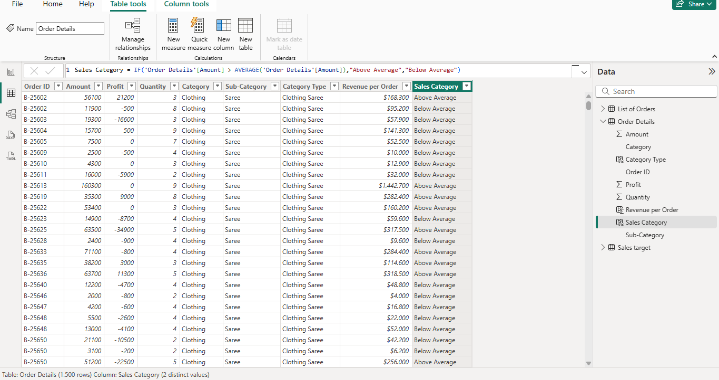
Calculated Measures:
Calculate Order Count: Define a measure to count the total number of orders in the
Order Details table.
Formula:
Order Count = DISTINCTCOUNT('Order Details'[Order ID])
Calculate Average Profit in Delhi: Create a measure to calculate the average profit for
orders placed in Delhi.
Formula:
Average Profit in Delhi =
CALCULATE( AVERAGE('Order Details'[Profit]),'List of Orders'[City] = "Delhi")
Calculate Year-to-Date (YTD) Sales: Define a measure to calculate the total sales
amount accumulated from the earliest order date up to each order date.
Formula:
YTD Sales =
TOTALYTD (SUM('Order Details'[Amount]),'List of Orders'[Order Date])

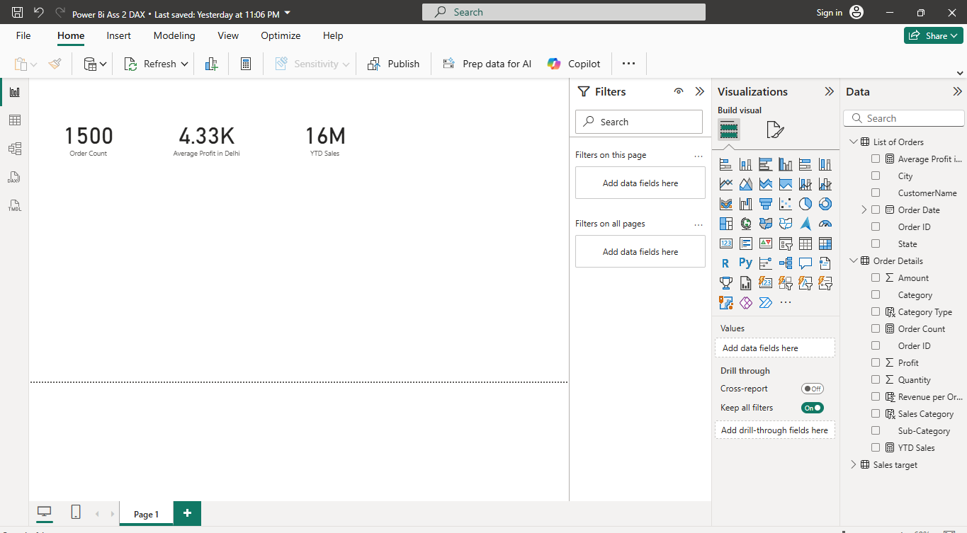

Data Visualization:
Sales Target Achievement by Category: Compare actual sales with sales targets by
category using a clustered column chart
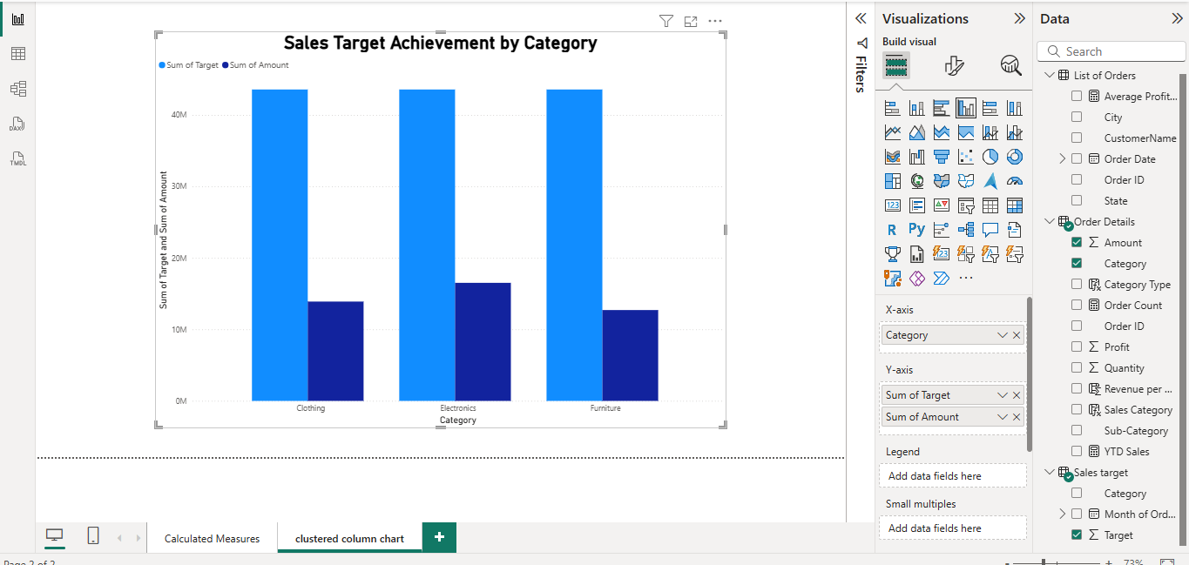

Max Profit Margin by Sub-Category: Analyze the maximum profit margin for each
sub-category of products using a donut chart.
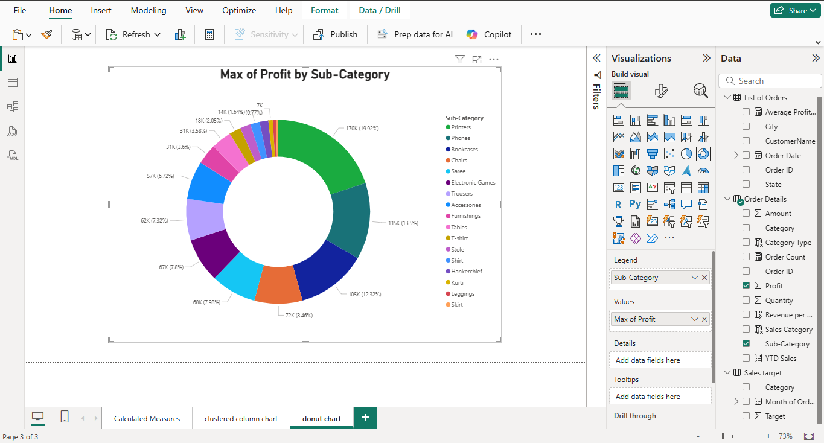

Monthly Sales Trend: Show the trend of monthly sales over time using a line chart.

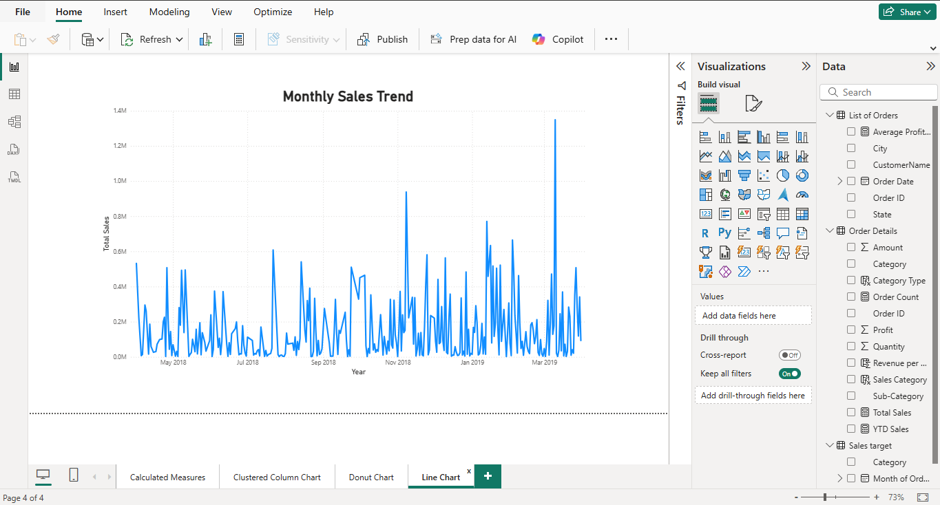

Comparison of Profit and Quantity by Sub-Category: Compare the relationship between
profit and quantity sold for different sub-categories using a scatter chart.

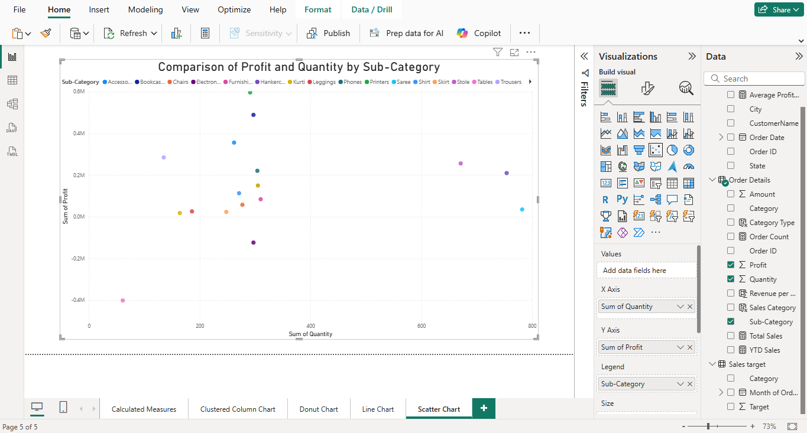

Comparison of Total Sales Amount and Target: Create cards to succinctly display the total
sales amount alongside the sales target for quick comparison and analysis. Also, create a
multi-row card to display the minimum target for each segment.

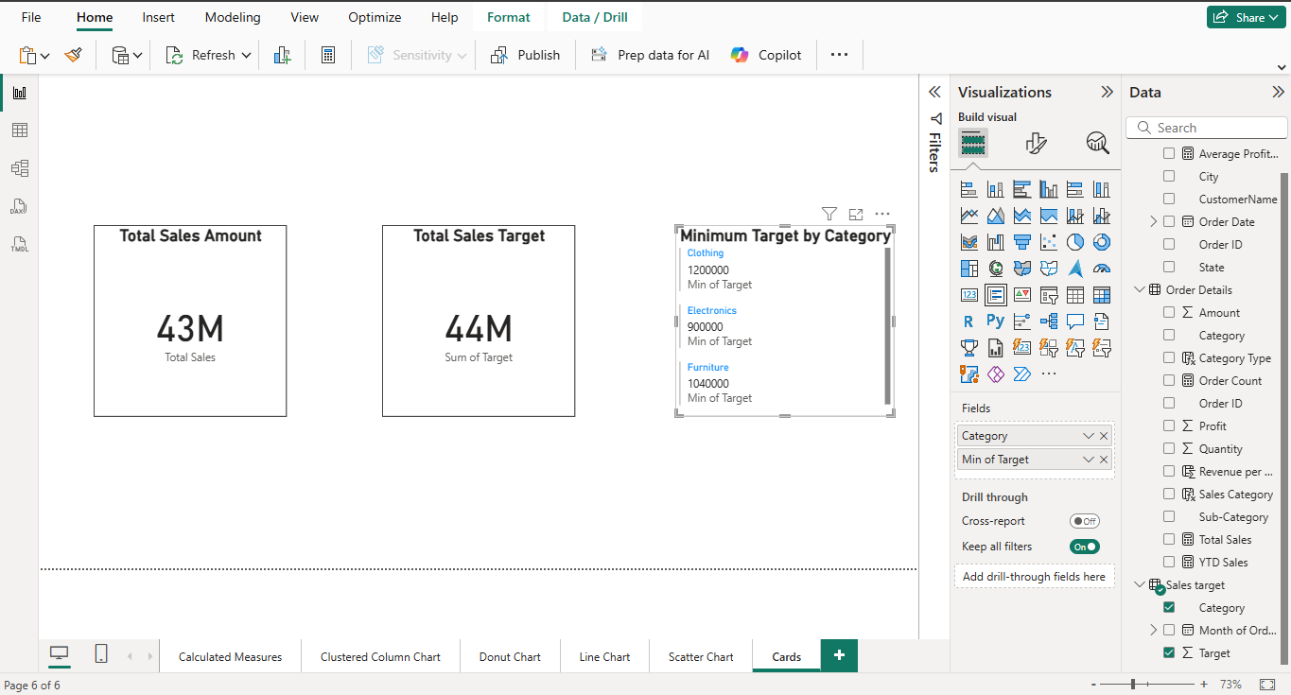

Sales Performance Matrix: Build a matrix view to analyze how actual sales compare to
sales targets across different categories and months.

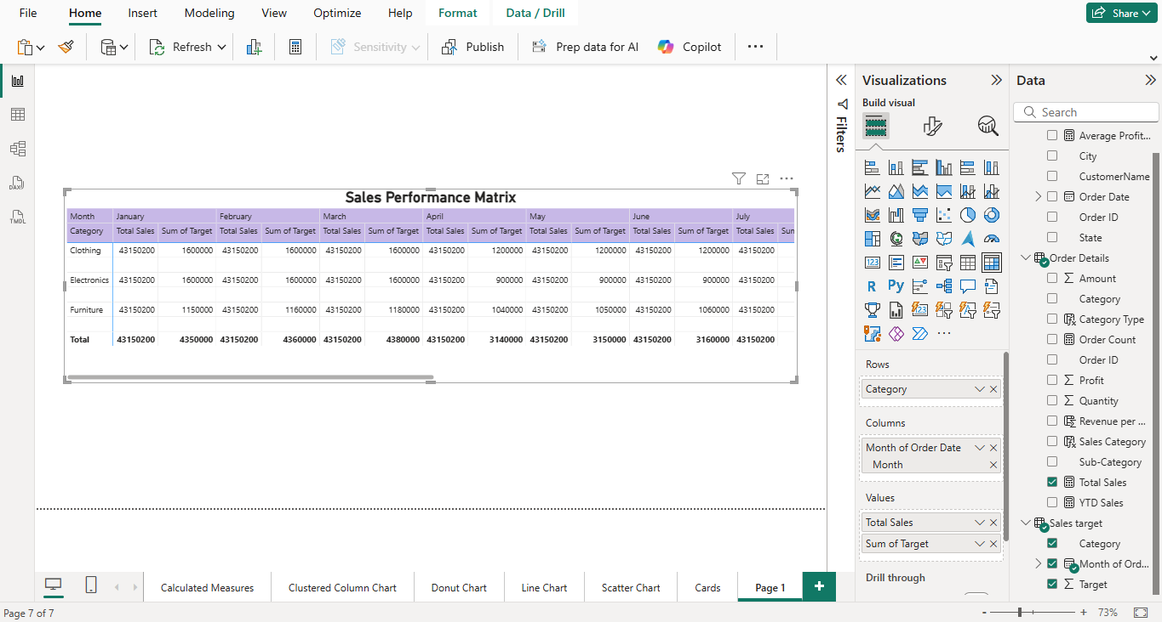
Geographic Sales Analysis: Visualize total sales on a map by city to identify regional sales
patterns.

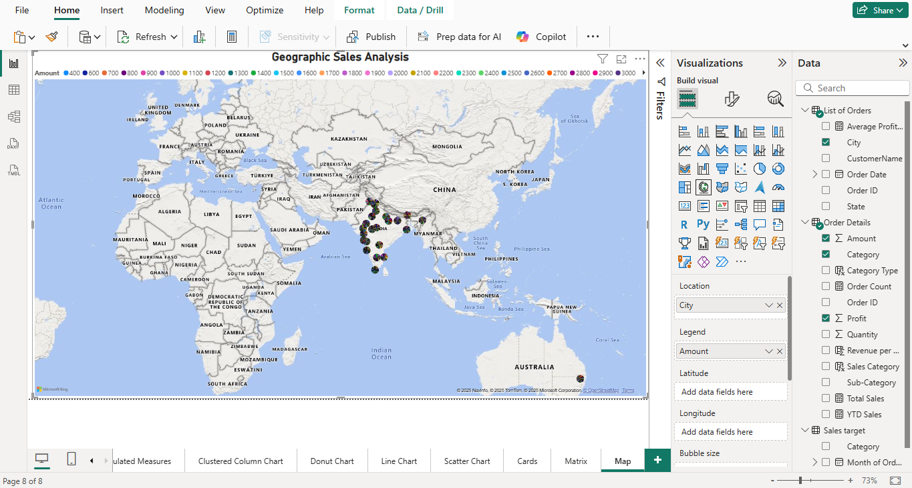

Sales Distribution by Sub-Category: Represent the sales distribution across different
sub-categories using a treemap.

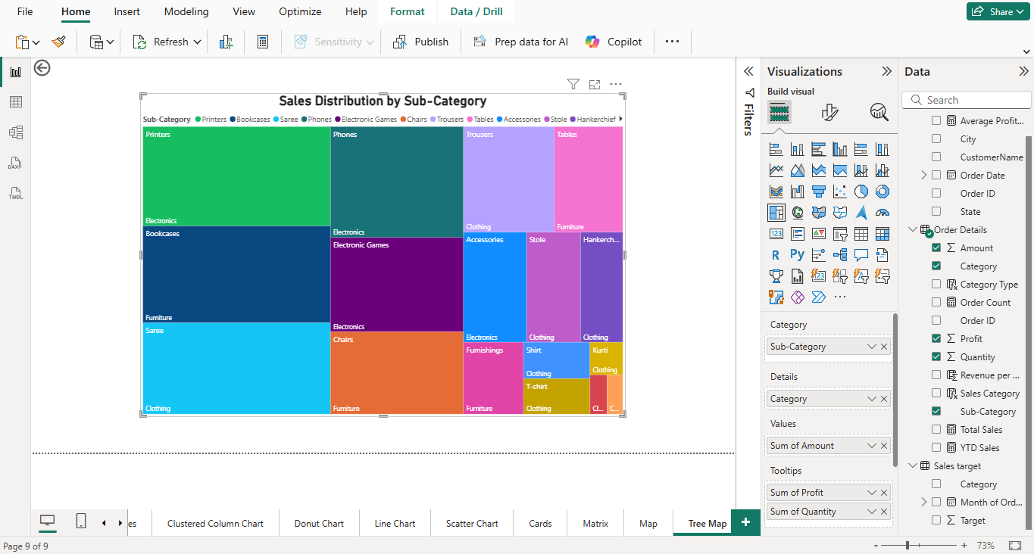

Order Count Analysis by State: Create a funnel chart to visualize the distribution of order
counts across different states.

